PROJECT SEMESTER REPORT

Zero-Touch
Device Onboarding
Project
by
Nikhil Sharma
Roll No. 102203474

Under the Guidance of

Mr. Vivek Gangwar
Senior Technical Manager

Mr. Ajay Hooda
Associate Director
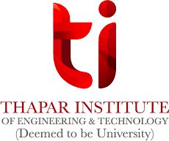

Submitted to the
Computer Science & Engineering Department Thapar Institute of Engineering & Technology, Patiala

In Partial Fulfillment of the Requirements for the Degree of Bachelor of Engineering in Computer Engineering
June 2026

Zero-Touch
Device Onboarding
Project

by
Nikhil Sharma

Place of Work: Incedo Inc.

Submitted to the
Computer Science & Engineering Department Thapar Institute of Engineering & Technology, Patiala

June 2026

In Partial Fulfillment of the Requirements for the Degree of Bachelor of Engineering in Computer Engineering

Abstract
The internship project focuses on the design and implementation of a Zero-Touch Onboarding (ZTO) solution for industrial edge devices within the Belden Horizon ecosystem. The work primarily involves understanding secure device identity provisioning, certificate-based authentication mechanisms, and automated onboarding workflows using Public Key Infrastructure (PKI). A complete certificate hierarchy was established using Trustpoint and OpenSSL, including Root CA, Intermediate CA, Domain CA, and application-level certificates. The project involved exploring Certificate Management Protocol (CMP), X.509 certificates, mutual TLS (mTLS), and WebSocket Secure (WSS) communication for enabling secure device-to-cloud interactions. Existing onboarding workflows based on shared certificates and manual activation mechanisms were analyzed to identify security and scalability limitations. A new architecture was proposed where each device is provisioned with a unique certificate and automatically authenticated using mTLS, eliminating the need for activation keys and manual onboarding. Practical exposure was gained in Golang-based backend development, secure communication protocols, certificate lifecycle management, Docker-based device simulation, and scalability validation. The internship also provided experience in system design, debugging, issue investigation, testing, and enterprise software development practices. Additionally, exposure was gained to Agile methodologies including Daily Scrum Meetings (DSM), sprint-based development, Jira-based task tracking, and collaborative engineering workflows followed in industrial projects.

Author
Nikhil Sharma

Certified by

Mr. Vivek Gangwar
Mr. Ajay Hooda

Certified by

Dr. Karun Verma
(Student Signature)

(Industrial Coordinator / Mentor)

(Faculty Mentor)

Internship Certificate

Contents

Abstract 1
List of Figures 4
List of Tables 5
- Company Profile 6
  - Organization Overview 6
  - Client and Project Ecosystem 6
  - Internship Domain and Exposure 7
- Introduction 9
  - Industrial IoT and Secure Device Onboarding Infrastructure 9
  - Project Overview 9
  - Zero-Touch Onboarding and Secure Device Management Systems 10
  - Industrial Development Environment 11
  - Project Contribution 11
- Background 13
  - Evolution of Secure Device Onboarding Systems 12
  - Public Key Infrastructure (PKI) and X.509 Certificates 16
  - Trustpoint and Certificate Management Protocol (CMP) 16
  - Mutual TLS (mTLS) Authentication 17
  - WebSocket Secure (WSS) Communication 17
  - Golang-Based Backend Systems 17
  - Industrial IoT Security and Zero-Touch Onboarding 18
  - Enterprise Development and Engineering Practices 18
- Objectives 19
- Methodology 20
  - Problem Understanding and Architecture Analysis 20
  - PKI and Certificate Infrastructure Development 20
  - Secure Communication and Authentication Workflow Study 21
  - Backend Development, Testing and Validation 21
  - Agile Development Workflow 22
  - Overall Workflow 23
  - Tools and Technology 28
- Observations and Findings 29
  - Zero-Touch Onboarding Architecture Understanding 29
  - PKI and Certificate Management Observations 29
  - Mutual TLS and Secure Communication Analysis 31
  - Backend Development and Implementation Findings 32
  - Docker-Based Testing and Validation Findings 33
  - Device and Tenant Management Observations 34
  - Overall Findings 37
- Limitations 38
  - Technical Limitations 38
  - Documentation and Security Constraints 38
  - Project Scope Limitations 39
- Conclusions and Future Work 40
  - Conclusion 40
  - Learning Outcomes 41
  - Future Work
Bibliography 26

List of Figures

- Enterprise Networking and Device Management Ecosystem 7

- High Level Zero-Touch Onboarding Architecture 10

- Traditional-Device Onboarding 15

- Zero-Touch Onboarding Flow 15
- Public Key Infrastructure using Trustpoint 23
- mutual-TLS Flow 24
- Websocket Connection Flow 25
- Device Onboarding Flow 26
- Cloud/Tenant UI 27
- Trustpoint Certificates 30
- Trustpoint Certificates Hierarchy 30
- TLS Handshake Logs 31
- Device-Onboarding Flow Logs 33
- Docker logs simulating multiple devices onboarding 34
- Device UI (showing onboarding Flow) 35
- Device UI (showing group chat Flow) 36
- Tenant/Cloud UI Login 36
- Tenant/Cloud UI showing successfully onboarded devices 37

List of Tables
- Traditional Networking vs Industrial Enterprise Networking 14
- Technologies and Tools Used During Internship 28

Company Profile


Organization Overview
Incedo Inc. is a global technology consulting and digital transformation company that provides advanced software engineering, analytics, cloud, and enterprise technology solutions across multiple industries including healthcare, financial services, telecommunications, and hi-tech domains. The company focuses on enabling enterprises to modernize their products, platforms, and operations using digital technologies, cloud systems, data engineering, artificial intelligence, and scalable software solutions.
The internship was carried out within the Hi-Tech division of Incedo Inc. The Hi-Tech division primarily focuses on helping technology companies transform from traditional product centric systems into intelligent, connected, and solution oriented platforms. The division works extensively on modern enterprise technologies involving industrial automation, communica-tion systems, embedded platforms, cloud integrated infrastructures, cybersecurity solutions, enterprise software systems, and intelligent networking platforms.
According to the company’s Hi-Tech division overview, Incedo partners with organizations working in industrial automation, communication equipment, data center infrastructure, cy-bersecurity, and enterprise software domains. The division focuses on developing intelligent embedded systems, scalable digital platforms, and AI driven software solutions while supporting modernization of enterprise infrastructures and operational workflows.

Client and Project Ecosystem
The client associated with the internship project is Belden Inc., a globally recognized com-pany specializing in industrial networking, communication infrastructure, automation systems, and connectivity solutions. Belden develops enterprise and industrial networking products including wireless access points, industrial switches, firewalls, communication systems, moni-toring platforms, and cloud integrated networking technologies used in industrial and enterprise environments.
The overall project ecosystem involves development and enhancement of a unified enterprise networking infrastructure that allows centralized monitoring, management, and configuration of multiple networking devices and communication systems. Different teams collaboratively work on various networking domains such as wireless networking, switching technologies, firewall systems, cloud integration, backend infrastructure, and operating system level services to build scalable and reliable enterprise networking solutions.

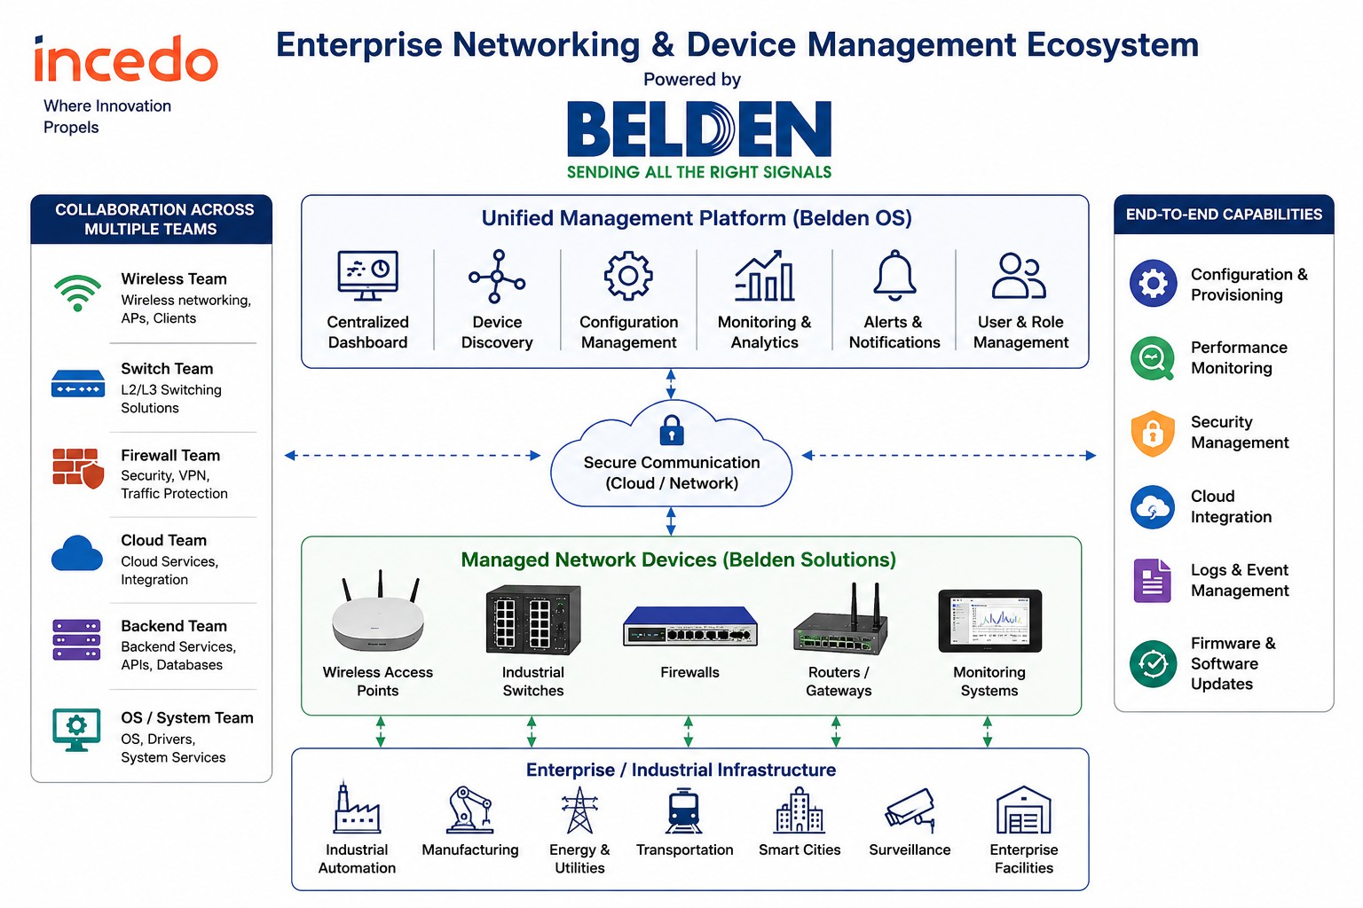
Figure 1: Enterprise Networking and Device Management Ecosystem

Internship Domain and Exposure
The internship was carried out in the domain of Industrial Internet of Things (IIoT), Device Security, Public Key Infrastructure (PKI), and Secure Device Onboarding Systems. The project primarily focused on understanding how industrial edge devices are securely provisioned, authenticated, and managed within the Belden Horizon ecosystem. The work involved studying device identity management, certificate-based authentication mechanisms, onboarding workflows, and secure communication architectures used in industrial environments.
The project was centered around the implementation of a Zero-Touch Onboarding (ZTO) architecture for OpEdge industrial edge devices. Existing onboarding workflows based on shared device certificates and manual activation mechanisms were analyzed to understand their security and scalability limitations. A new onboarding model was proposed where each device is provisioned with a unique X.509 certificate and automatically authenticated using certificate-based trust mechanisms. This architecture helps eliminate manual activation processes, improve security, and simplify large-scale device deployments.

The internship also involved understanding the complete lifecycle of digital certificates within a Public Key Infrastructure. Exposure was gained in designing and managing certificate hierarchies consisting of Root CA, Intermediate CA, Domain CA, and application-level certificates using OpenSSL and Trustpoint. Certificate Management Protocol (CMP) workflows were explored to understand automated certificate enrollment, issuance, renewal, and lifecycle management processes used in enterprise-grade security infrastructures.
In addition to PKI-related activities, practical exposure was gained in implementing secure communication using mutual TLS (mTLS) and WebSocket Secure (WSS). The project involved understanding how devices establish trusted connections with cloud services, how certificate chains are validated, and how onboarding status and lifecycle information can be exchanged securely between devices and backend systems. Backend development activities included exploring Golang-based services, onboarding agents, communication workflows, metadata validation mechanisms, and tenant association logic used within the onboarding architecture.
The internship also provided hands-on experience with Docker and Docker Compose for simulating multiple device instances and validating onboarding workflows at scale. Exposure was gained in debugging certificate validation issues, analyzing TLS handshake processes, troubleshooting WebSocket communication, configuring trust stores, and investigating interoperability challenges between different PKI components. These activities helped develop a deeper understanding of secure device onboarding systems and enterprise-scale security architectures.
The internship additionally provided understanding of Agile software development methodologies followed in industrial environments. Activities such as Daily Scrum Meetings (DSM), sprint planning, Jira-based task tracking, collaborative problem-solving sessions, and regular project reviews helped in understanding professional software engineering workflows and large-scale enterprise project execution practices.
Overall, the internship at Incedo Inc. provided valuable exposure to Industrial IoT systems, secure device onboarding architectures, PKI-based identity management, certificate lifecycle management, backend system development, cloud-device communication, and real-world implementation of security solutions used in large-scale industrial and enterprise environments.

Introduction

Industrial IoT and Secure Device Onboarding Infrastructure
Modern enterprise and industrial infrastructures heavily depend on reliable networking sys-tems, backend communication platforms, operating system level services, and scalable software architectures to support automation, centralized management, real time monitoring, and se-cure communication across interconnected environments. Rapid advancements in industrial automation, cloud integrated systems, enterprise communication technologies, and intelligent networking platforms have significantly increased the demand for scalable and efficient solutions capable of managing large numbers of interconnected devices and backend services.
Industrial networking environments are significantly more complex than traditional small scale networking systems because they involve continuous communication between wireless devices, switches, firewall systems, backend servers, cloud integrated services, monitoring platforms, and centralized management infrastructures. Such systems require efficient runtime management, stable communication workflows, reliable configuration handling, secure data exchange, and robust backend processing mechanisms to ensure uninterrupted operation under dynamic network conditions.

Project Overview
This internship project focuses on understanding and implementing a secure Zero-Touch Onboarding (ZTO) architecture for industrial edge devices operating within the Belden Horizon ecosystem. The primary emphasis of the project is on secure device identity provisioning, certificate-based authentication, automated onboarding workflows, and secure device-to-cloud communication. In addition to Zero-Touch Onboarding, the project also provides exposure to Public Key Infrastructure (PKI), certificate lifecycle management, backend software engineering, secure communication protocols, cloud-based device management systems, and enterprise security architectures.
The internship work was carried out within the Hi-Tech division of Incedo Inc. in collaboration with Belden Inc. The Hi-Tech division primarily focuses on the development and modernization of enterprise platforms, industrial automation solutions, cloud-integrated systems, cybersecurity technologies, and intelligent edge computing infrastructures. Multiple teams collaboratively work on device management platforms, backend services, cloud technologies, security solutions, and communication systems to build scalable and secure industrial ecosystems.
The project ecosystem associated with Belden involves management of industrial edge devices through the Belden Horizon platform. Devices such as OpEdge 4D and OpEdge 8D gateways are deployed across industrial environments and require secure onboarding, authentication, monitoring, and lifecycle management. The infrastructure includes industrial edge devices, backend onboarding services, certificate management systems, cloud management platforms, and secure communication channels working together to provide scalable, reliable, and secure device management solutions for industrial and enterprise deployments.

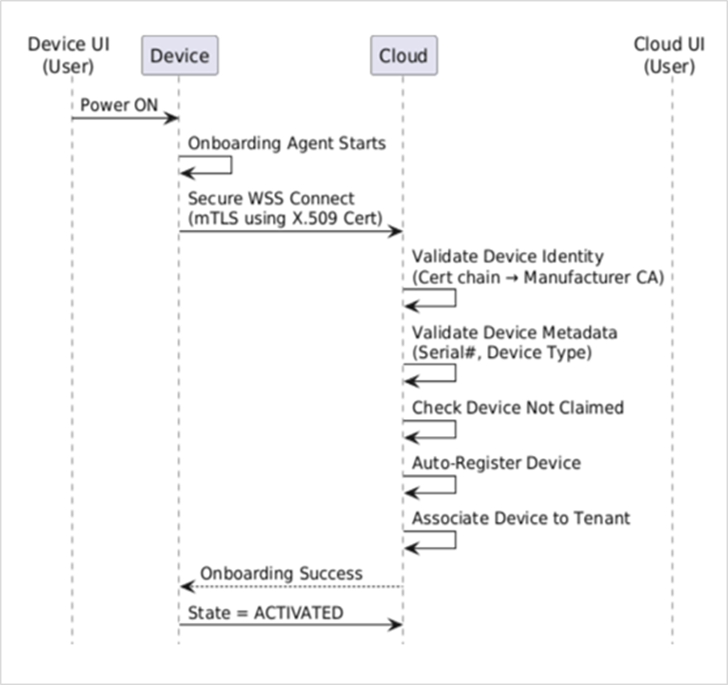
Figure 2: High Level Zero-Touch Onboarding Architecture

Zero-Touch Onboarding and Secure Device Management Systems
A major part of the internship involved understanding secure device onboarding workflows associated with industrial edge devices, certificate-based authentication mechanisms, Public Key Infrastructure (PKI), and cloud-integrated device management platforms. The work included studying device identity provisioning, certificate enrollment processes, certificate lifecycle management, mutual TLS (mTLS) authentication, and secure communication workflows using WebSocket Secure (WSS). Existing onboarding architectures based on shared certificates and manual activation mechanisms were analyzed to understand their operational limitations and security challenges.
In addition to security concepts, the internship provided practical exposure to Trustpoint, OpenSSL, Certificate Management Protocol (CMP), Golang-based backend services, and Docker-based deployment environments. Existing onboarding workflows, certificate validation mechanisms, backend communication processes, and tenant association logic were analyzed to understand system behavior, authentication workflows, runtime interactions, and security controls associated with industrial device onboarding infrastructures. Practical exposure was also gained in certificate chain validation, trust store management, TLS debugging, WebSocket communication, and troubleshooting techniques commonly used in enterprise security systems.
The project also provided understanding of how secure onboarding platforms are designed, implemented, tested, and maintained within large-scale industrial environments. Practical exposure was gained in backend system analysis, onboarding workflow design, scalability validation, debugging activities, certificate management operations, and collaborative engineering practices used in production-oriented Industrial IoT ecosystems. This helped in developing a broader understanding of enterprise security architectures and the importance of automated identity management in modern industrial deployments.

Industrial Development Environment
The internship additionally provided exposure to Agile software development methodologies followed in enterprise environments. Participation in Daily Scrum Meetings (DSM), sprint planning activities, Jira-based task management, collaborative design discussions, and regular project review sessions helped in understanding enterprise project execution workflows, team collaboration practices, and software development lifecycle management processes followed in large-scale industrial projects. Exposure was also gained in requirement analysis, architecture discussions, issue tracking, documentation practices, and structured development workflows used for building secure and scalable industrial software solutions.

Project Contribution
Overall, the project contributes toward bridging the gap between theoretical concepts of cybersecurity, Public Key Infrastructure (PKI), computer networks, secure communication protocols, and practical implementation of industrial device onboarding systems. The internship provided valuable exposure to certificate-based authentication, device identity management, cloud-device communication, backend software development, and enterprise security architectures. It also helped in understanding how modern Industrial IoT platforms leverage PKI, X.509 certificates, mTLS, WebSocket Secure (WSS), and automated onboarding workflows to securely manage large fleets of industrial devices in real-world enterprise environments.

Background

Evolution of Secure Device Onboarding Systems
The rapid growth of Industrial Internet of Things (IIoT), edge computing, cloud-based management platforms, and connected industrial devices has significantly transformed the way devices are deployed and managed within modern industrial environments. Traditional device onboarding approaches relied heavily on manual configuration, shared credentials, and activation-key-based workflows. While these methods were suitable for smaller deployments, they introduced operational challenges and security risks when managing large fleets of devices distributed across multiple locations.
In modern industrial ecosystems, devices are expected to securely authenticate themselves, establish trusted communication channels, and integrate with centralized management platforms without requiring manual intervention. Industrial edge devices continuously interact with cloud services, backend systems, certificate authorities, and monitoring platforms to support secure communication, lifecycle management, remote operations, and automated provisioning. Such environments require robust identity management systems capable of securely managing device credentials, certificates, and trust relationships throughout the device lifecycle.
As industrial deployments continue to scale, organizations are increasingly adopting certificate-based Zero-Touch Onboarding (ZTO) architectures to automate device provisioning and authentication processes. Modern onboarding systems leverage Public Key Infrastructure (PKI), X.509 certificates, Certificate Management Protocol (CMP), mutual TLS (mTLS), and secure communication protocols to establish device trust and identity. This evolution has significantly improved security, scalability, and operational efficiency by replacing manual onboarding processes with automated certificate-based trust models capable of supporting enterprise-scale industrial deployments.

Table 1: Traditional Networking vs Industrial Enterprise Networking

Traditional Device Onboarding | Zero-Touch Onboarding (Proposed System)
Shared device certificates across multiple devices | Unique X.509 certificate for each device
Manual activation using activation keys | Automatic onboarding without user intervention
Tenant association performed manually | Automatic tenant association based on device identity
Higher operational overhead | Reduced operational effort and faster deployment
Difficult to scale for large device fleets | Designed for large-scale industrial deployments
Security risks due to credential sharing | Strong security through PKI and mTLS
Multiple manual onboarding steps | Fully automated onboarding workflow
Limited onboarding visibility and automation | Real-time onboarding status through WebSocket communication
Higher deployment time | Faster and more scalable device provisioning

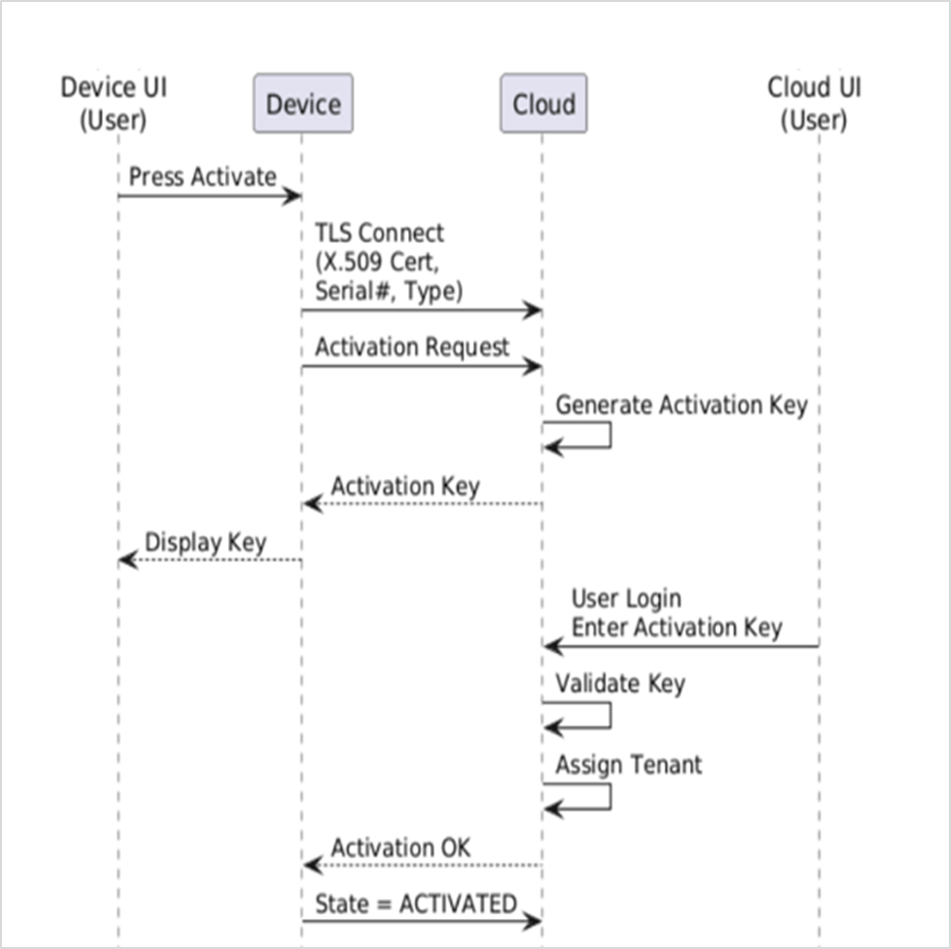

Fig 3: Traditional-Device Onboarding Flow



Fig 4: Zero-Touch Onboarding Flow

Public Key Infrastructure (PKI) and X.509 Certificates
Public Key Infrastructure (PKI) forms the foundation of modern certificate-based security systems and plays a critical role in establishing trust between devices and services. PKI uses a hierarchical trust model consisting of Certificate Authorities (CAs) responsible for issuing, validating, and managing digital certificates. In industrial IoT environments, PKI enables secure device identity management by assigning a unique cryptographic identity to each device through X.509 certificates.
X.509 certificates contain information such as device identity, issuer details, validity period, public keys, and certificate extensions. These certificates allow devices and servers to verify each other's identity before establishing communication. During this internship, a complete certificate hierarchy consisting of Root CA, Intermediate CA, Domain CA, and application-level certificates was created using OpenSSL and Trustpoint. This hierarchy formed the trust foundation for implementing secure device onboarding and certificate-based authentication workflows.

Trustpoint and Certificate Management Protocol (CMP)
Trustpoint is an open-source Public Key Infrastructure platform that provides certificate lifecycle management, certificate issuance, enrollment workflows, and identity provisioning services. It simplifies certificate management by automating certificate generation, validation, renewal, and revocation processes while maintaining a centralized trust model.
The project involved exploring Certificate Management Protocol (CMP), which is used to automate certificate enrollment and lifecycle operations between devices and certificate authorities. Through CMP workflows, devices can securely request, obtain, and renew certificates without manual intervention. Understanding Trustpoint and CMP helped in developing the certificate provisioning mechanisms required for implementing a scalable Zero-Touch Onboarding architecture.

Mutual TLS (mTLS) Authentication
Mutual TLS (mTLS) is an authentication mechanism where both the client and server verify each other's identities using digital certificates before establishing communication. Unlike traditional TLS, which only verifies the server identity, mTLS ensures bidirectional trust and significantly improves security.
In the proposed onboarding architecture, devices authenticate themselves using unique X.509 certificates during connection establishment. The cloud validates the certificate chain against trusted Certificate Authorities and verifies device identity before allowing onboarding operations. This approach eliminates the need for shared credentials, passwords, and activation keys while ensuring that only trusted devices can communicate with backend services.

WebSocket Secure (WSS) Communication
WebSocket Secure (WSS) is a communication protocol that enables persistent, full-duplex communication between clients and servers over a secure TLS channel. Unlike REST APIs, which rely on repeated request-response cycles, WebSocket maintains a persistent connection that allows both endpoints to exchange information in real time.
WebSocket was selected for the onboarding architecture because device onboarding workflows require continuous status updates, activation state notifications, and future support for real-time device communication. Using REST APIs for such workflows would require frequent polling, resulting in increased network overhead and higher server load. WebSocket provides a more efficient solution by maintaining a persistent connection and enabling real-time bidirectional communication between devices and cloud services.
3.6 Golang-Based Backend Systems
Golang has become a widely adopted language for backend and distributed systems due to its simplicity, performance, and strong concurrency support. One of its most significant features is the use of lightweight goroutines, which allow thousands of concurrent operations to execute efficiently with minimal resource consumption.
The project explored Golang for implementing onboarding agents, backend services, secure communication workflows, and device management components. Golang provides strong support for networking, TLS, WebSocket communication, and concurrent processing through its standard library. These capabilities make it highly suitable for developing scalable backend systems capable of handling large numbers of simultaneously connected devices in industrial IoT environments.
3.7 Industrial IoT Security and Zero-Touch Onboarding
As industrial deployments continue to grow, managing device identities and onboarding workflows manually becomes increasingly difficult. Traditional onboarding approaches often rely on activation keys, shared credentials, and manual registration processes, which create operational overhead and security risks.
Zero-Touch Onboarding (ZTO) addresses these challenges by enabling devices to automatically authenticate, register, and establish trusted communication channels without requiring human intervention. The architecture combines PKI, X.509 certificates, CMP, mTLS, and WebSocket communication to create a secure and scalable onboarding framework. This approach improves security, reduces deployment effort, and supports large-scale industrial device deployments through automated identity provisioning and lifecycle management.
3.8 Enterprise Development and Engineering Practices
The project environment associated with this internship involved collaboration across multiple domains including device security, backend development, certificate management, cloud services, and industrial IoT platforms. Multiple engineering teams work together to build secure onboarding systems, device management services, communication infrastructures, and cloud-based monitoring solutions capable of supporting enterprise-scale deployments.
The internship also provided understanding of professional software engineering workflows followed in industrial environments. Activities such as Daily Scrum Meetings (DSM), sprint planning sessions, Jira-based task tracking, collaborative debugging activities, design discussions, and project review meetings were regularly followed to manage development tasks and coordinate project execution efficiently. Exposure to these methodologies helped in understanding real-world software development lifecycle management practices used in enterprise organizations.

Objectives

- To understand Industrial Internet of Things (IIoT) ecosystems and industrial device management infrastructures involving edge devices, cloud platforms, backend services, certificate authorities, and centralized management systems used in large-scale industrial environments.
- To study Public Key Infrastructure (PKI), X.509 certificates, certificate hierarchies, certificate lifecycle management processes, and secure identity provisioning mechanisms used for establishing trust between devices and cloud services.
- To analyze existing device onboarding workflows and understand the security, scalability, and operational challenges associated with shared certificates, activation-key-based onboarding, and manual tenant association mechanisms.
- To understand certificate-based authentication mechanisms including TLS, mutual TLS (mTLS), certificate validation workflows, trust store management, certificate chain verification, and secure communication architectures used in Industrial IoT systems..
- To study Trustpoint and Certificate Management Protocol (CMP) workflows for automated certificate enrollment, issuance, renewal, validation, and lifecycle management within enterprise security infrastructures.
- To design and implement a Zero-Touch Onboarding (ZTO) architecture that enables automated device registration, secure authentication, tenant association, and lifecycle state management without requiring manual user intervention.
- To gain practical exposure to Golang-based backend development, WebSocket Secure (WSS) communication, Docker-based device simulation, scalability validation, debugging activities, and enterprise software engineering methodologies including Agile development workflows, Daily Scrum Meetings (DSM), Jira-based task management, and sprint planning processes.
- To bridge the gap between theoretical concepts of cybersecurity, computer networks, secure communication protocols, Public Key Infrastructure, backend software engineering, and practical implementation of secure device onboarding systems used in industrial and enterprise environments.

Methodology

Problem Understanding and Architecture Analysis
The methodology followed during the internship primarily focused on understanding industrial device onboarding architectures, certificate-based authentication systems, secure communication workflows, and Public Key Infrastructure (PKI) concepts used in Industrial IoT environments. Since the project involved designing and implementing a Zero-Touch Onboarding (ZTO) solution for industrial edge devices, the methodology emphasized architecture analysis, certificate lifecycle understanding, backend workflow design, implementation, testing, and validation of secure onboarding mechanisms rather than studying isolated software components.
The overall workflow of the project involved interaction between multiple layers including industrial edge devices, certificate authorities, backend onboarding services, cloud management platforms, and secure communication protocols. The internship work mainly focused on understanding how these components interact to establish device trust, automate onboarding workflows, and securely manage device identities within industrial environments.
The initial phase of the internship involved understanding the existing onboarding architecture used within the Belden ecosystem. Existing activation-key-based onboarding workflows, shared certificate mechanisms, tenant association processes, and device lifecycle management procedures were analyzed to identify security limitations, operational challenges, and scalability concerns associated with large-scale device deployments.

PKI and Certificate Infrastructure Development
A major part of the methodology involved studying and implementing Public Key Infrastructure (PKI) concepts using OpenSSL and Trustpoint. Certificate hierarchies consisting of Root CA, Intermediate CA, Domain CA, and application-level certificates were created to establish a secure chain of trust. X.509 certificate structures, certificate extensions, trust relationships, and certificate validation mechanisms were explored to understand how digital identities are established and maintained within enterprise security infrastructures.

The project also involved understanding Certificate Management Protocol (CMP) workflows for automated certificate enrollment and lifecycle management. Device certificates, TLS server certificates, and TLS client certificates were generated and validated to support secure authentication workflows. Activities such as certificate generation, certificate chain verification, trust store configuration, certificate renewal understanding, and lifecycle management analysis were performed to gain practical exposure to enterprise-grade PKI environments.
5.3 Secure Communication and Authentication Workflow Study
Another important part of the methodology involved studying secure communication protocols and authentication mechanisms used within Zero-Touch Onboarding architectures. Mutual TLS (mTLS) authentication workflows were analyzed to understand how devices and cloud services establish trusted communication channels through certificate-based identity verification.
The project additionally involved studying WebSocket Secure (WSS) communication mechanisms for enabling persistent and bidirectional communication between devices and cloud services. Communication workflows related to device onboarding requests, onboarding status notifications, activation state updates, metadata validation, and device registration processes were analyzed to understand secure device-to-cloud interaction mechanisms. Existing REST-based approaches were also evaluated to understand the advantages of WebSocket communication for real-time onboarding workflows.
5.4 Backend Development, Testing and Validation
Backend development and validation formed a major part of the internship workflow. Golang was explored for implementing onboarding services, communication modules, device registration workflows, certificate validation mechanisms, and tenant association logic. Existing communication workflows and backend architectures were analyzed to understand how scalable device onboarding services can be designed for enterprise deployments.
The project also involved testing and validation of onboarding workflows using Docker-based device simulation. Multiple device instances were simulated using Docker containers to validate onboarding behavior, certificate validation processes, communication workflows, and scalability characteristics of the proposed architecture. Activities such as certificate validation testing, mTLS handshake verification, WebSocket communication testing, onboarding state validation, and issue investigation were performed to understand practical deployment challenges associated with industrial onboarding systems.
5.5 Agile Development Workflow
The internship methodology also included exposure to enterprise software engineering workflows and Agile development practices. Activities such as Daily Scrum Meetings (DSM), sprint discussions, Jira-based task tracking, collaborative architecture discussions, debugging sessions, and project review meetings were regularly followed to understand project execution methodologies, collaborative engineering practices, and software development lifecycle management within industrial environments.
Continuous interaction with mentors and team members helped in understanding requirement analysis, architecture design decisions, implementation strategies, debugging methodologies, and validation approaches followed during enterprise software development. Exposure to these activities provided valuable insight into real-world engineering workflows and industrial project execution practices.

5.6 Overall Workflow

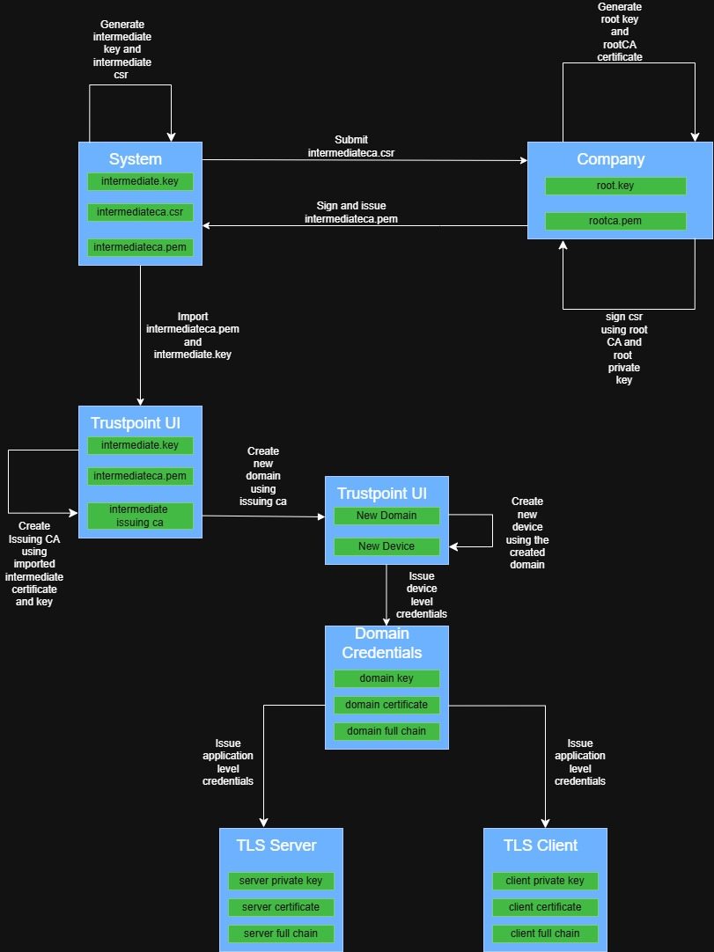
Figure 5: Public Key Infrastructure using Trustpoint
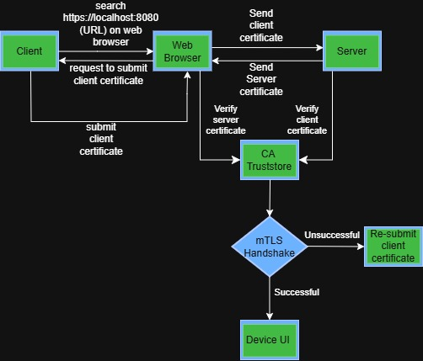
Figure 6: mutual-TLS Flow

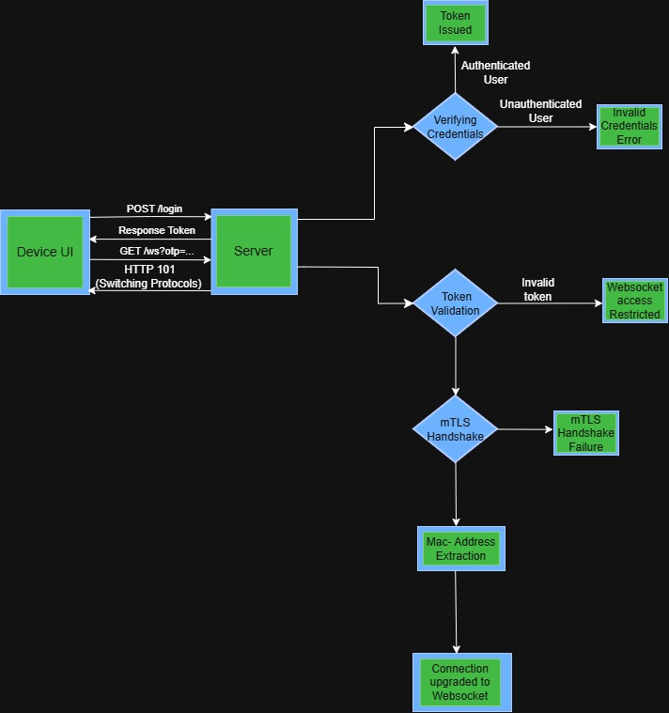
Figure 7: Websocket Connection Flow
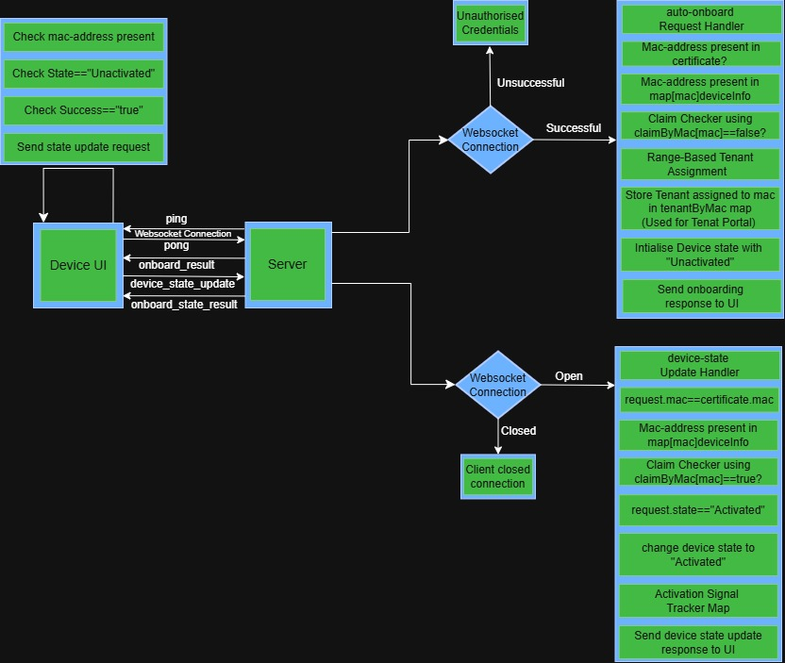
Figure 8: Device Onboarding Flow
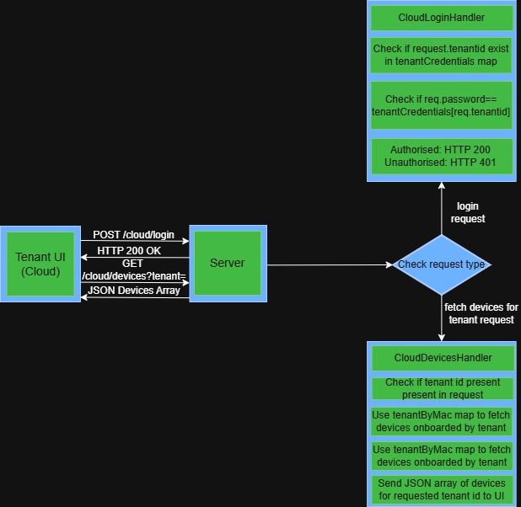
Figure 9: Cloud/Tenant UI Flow

The overall methodology adopted during the internship can be summarized as a continuous workflow involving architecture analysis, PKI implementation, certificate management, secure communication design, backend development, onboarding workflow validation, Docker-based scalability testing, and collaborative software engineering practices. This methodology helped in understanding the practical implementation of Zero-Touch Onboarding systems and provided valuable exposure to enterprise-grade security architectures used in Industrial IoT environments.

Tools and Technology

Table 2: Technologies and Tools Used During Internship

Technology / Tool | Purpose
Golang (Go) | Development of onboarding services, backend communication workflows, and device onboarding agents
Trustpoint | PKI management, certificate issuance, certificate lifecycle management, and identity provisioning
OpenSSL | Creation of Root CA, Intermediate CA, certificate generation, and certificate validation workflows
X.509 Certificates | Establishing unique device identities and certificate-based authentication
Mutual TLS (mTLS) | Persistent and real-time communication between devices and onboarding services
Docker & Docker Compose | Simulation of multiple device instances and scalability validation of onboarding workflows
Bitbucket | Version control and collaborative development workflow management
Jira | task tracking, and Agile project managemen

Observations and Findings

Zero-Touch Onboarding Architecture Understanding
During the internship, significant understanding was gained regarding Industrial IoT ecosystems, secure device onboarding architectures, certificate-based authentication systems, and cloud-device communication workflows used in industrial environments. The internship provided practical exposure to how edge devices, certificate authorities, onboarding services, cloud platforms, and communication protocols interact together to establish secure and scalable device management infrastructures.
One of the major observations during the internship was the complexity involved in managing large fleets of industrial devices compared to traditional device deployments. Industrial environments require secure device identity management, automated provisioning mechanisms, certificate lifecycle management, tenant association workflows, and continuous communication between devices and cloud platforms. Understanding these interactions helped in realizing the importance of scalable onboarding architectures and automated trust establishment mechanisms used in enterprise-grade Industrial IoT environments.

PKI and Certificate Management Observations
The internship provided practical understanding of Public Key Infrastructure (PKI), certificate hierarchies, and digital identity management systems. Exposure was gained to Root CA, Intermediate CA, Domain CA, application certificates, certificate chains, trust stores, and certificate validation mechanisms commonly used within enterprise security infrastructures. Understanding how certificate hierarchies establish trust relationships between devices and backend systems was an important learning outcome during the internship.
Another important observation was related to certificate lifecycle management and automated certificate provisioning workflows. Trustpoint and Certificate Management Protocol (CMP) were explored to understand how certificates are issued, validated, renewed, and managed throughout their lifecycle. The internship helped in understanding how enterprise systems use PKI to establish device identity, automate certificate management, and eliminate dependency on shared credentials and manual onboarding processes.
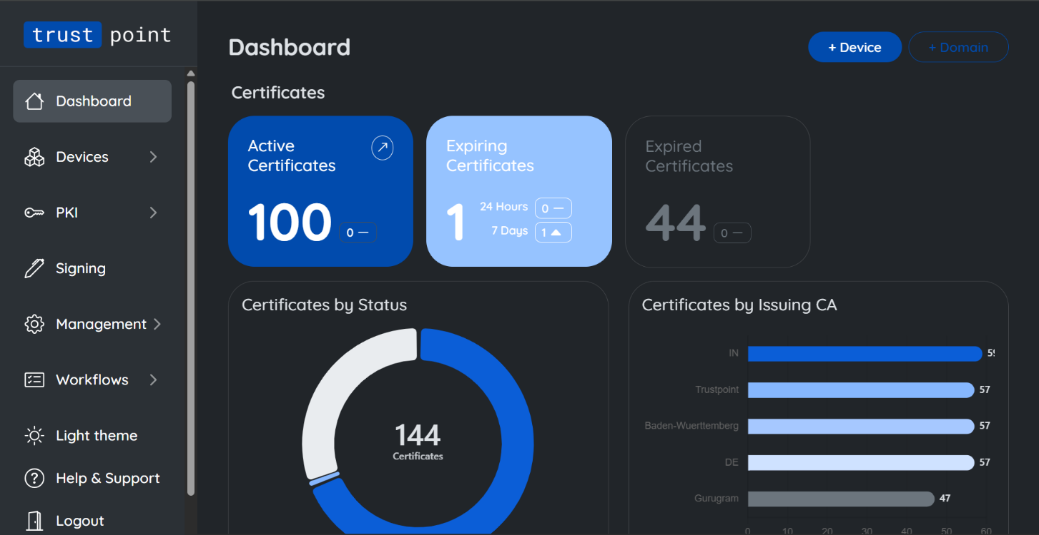
Fig 10: Trustpoint Certificates
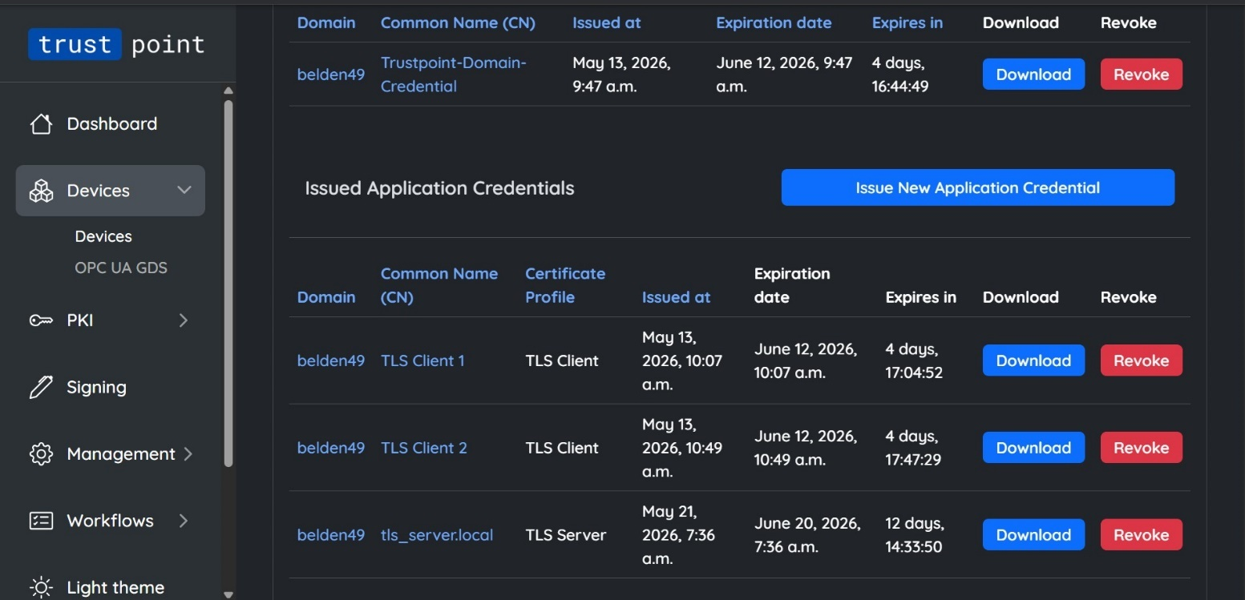
Fig 11: Trustpoint Certificates Hierarchy

Mutual TLS and Secure Communication Analysis
The project also provided understanding of secure communication mechanisms associated with TLS, mutual TLS (mTLS), certificate validation, and secure device authentication. Existing communication workflows were analyzed to understand how devices establish trusted communication channels with backend services through certificate-based authentication.
A major observation was the security advantage provided by mTLS over traditional authentication mechanisms. Unlike password-based authentication systems, mTLS allows both client and server to verify each other's identity using trusted certificates before communication is established. This significantly improves security and reduces risks associated with shared credentials and unauthorized device access. Exposure to TLS handshake processes, certificate validation workflows, trust store configuration, and communication debugging helped in understanding practical security implementations used in industrial environments.
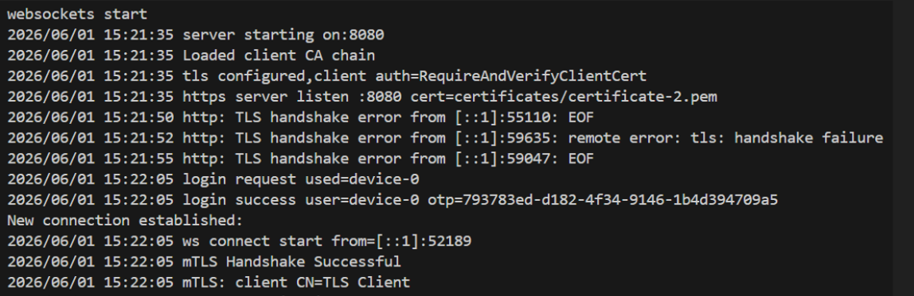
Fig 12: TLS Handshake Logs

Backend Development and Implementation Findings
Backend development and implementation activities formed a significant part of the internship learning experience. Practical exposure was gained in Golang-based backend development, onboarding workflow design, device registration mechanisms, tenant association logic, and communication service implementation. Existing onboarding workflows and backend architectures were analyzed to understand how scalable onboarding services can be designed for large-scale industrial deployments.
Another important observation was the suitability of Golang for backend and distributed systems. Golang provides strong support for networking, TLS communication, WebSockets, and concurrent processing through lightweight goroutines. Understanding how concurrent device connections can be efficiently managed using Golang helped in realizing its advantages for Industrial IoT and cloud-connected device management systems.
The project also involved understanding WebSocket Secure (WSS) communication mechanisms. Compared to traditional REST-based communication, WebSockets provide persistent and bidirectional communication channels, making them highly suitable for onboarding status updates, activation notifications, and future real-time device interactions. This helped in understanding practical communication design decisions used in modern distributed systems.
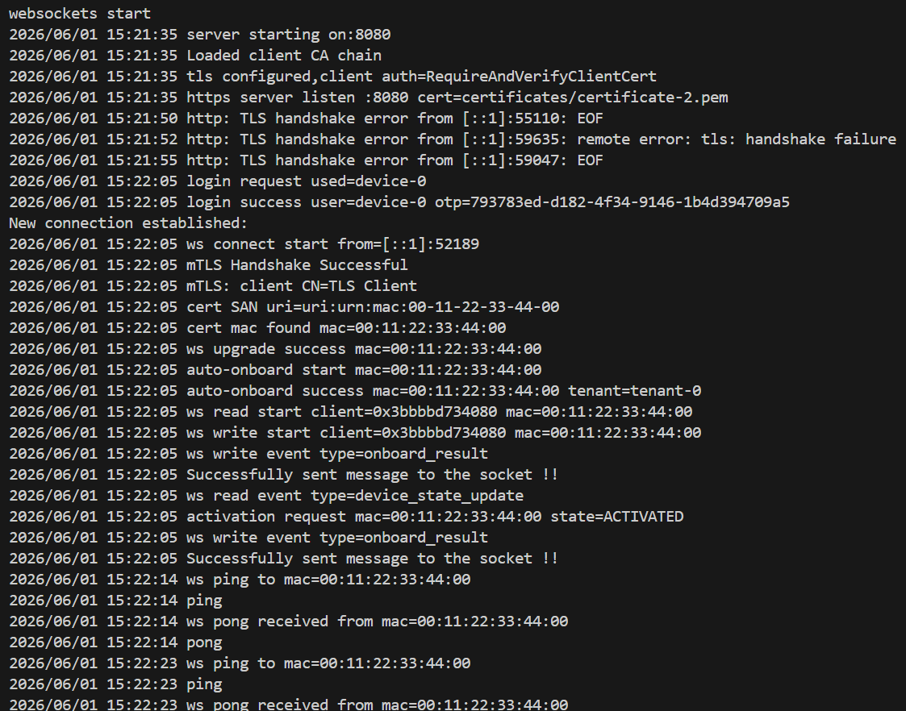
Fig 13: Device-Onboarding Flow Logs

Docker-Based Testing and Validation Findings
Testing and validation formed a major part of the internship workflow. Docker containers and Docker Compose were used to simulate multiple device instances and validate onboarding workflows under scalable deployment conditions. Multiple devices were configured to communicate with the onboarding backend, helping evaluate certificate validation processes, onboarding behavior, communication reliability, and overall system scalability.
A major observation during testing was the effectiveness of container-based simulations in validating enterprise-scale onboarding workflows. Docker-based deployments enabled rapid testing of onboarding scenarios, certificate authentication mechanisms, and communication workflows without requiring physical hardware for each device instance. This helped in understanding practical approaches used to validate scalability and deployment readiness of distributed systems.
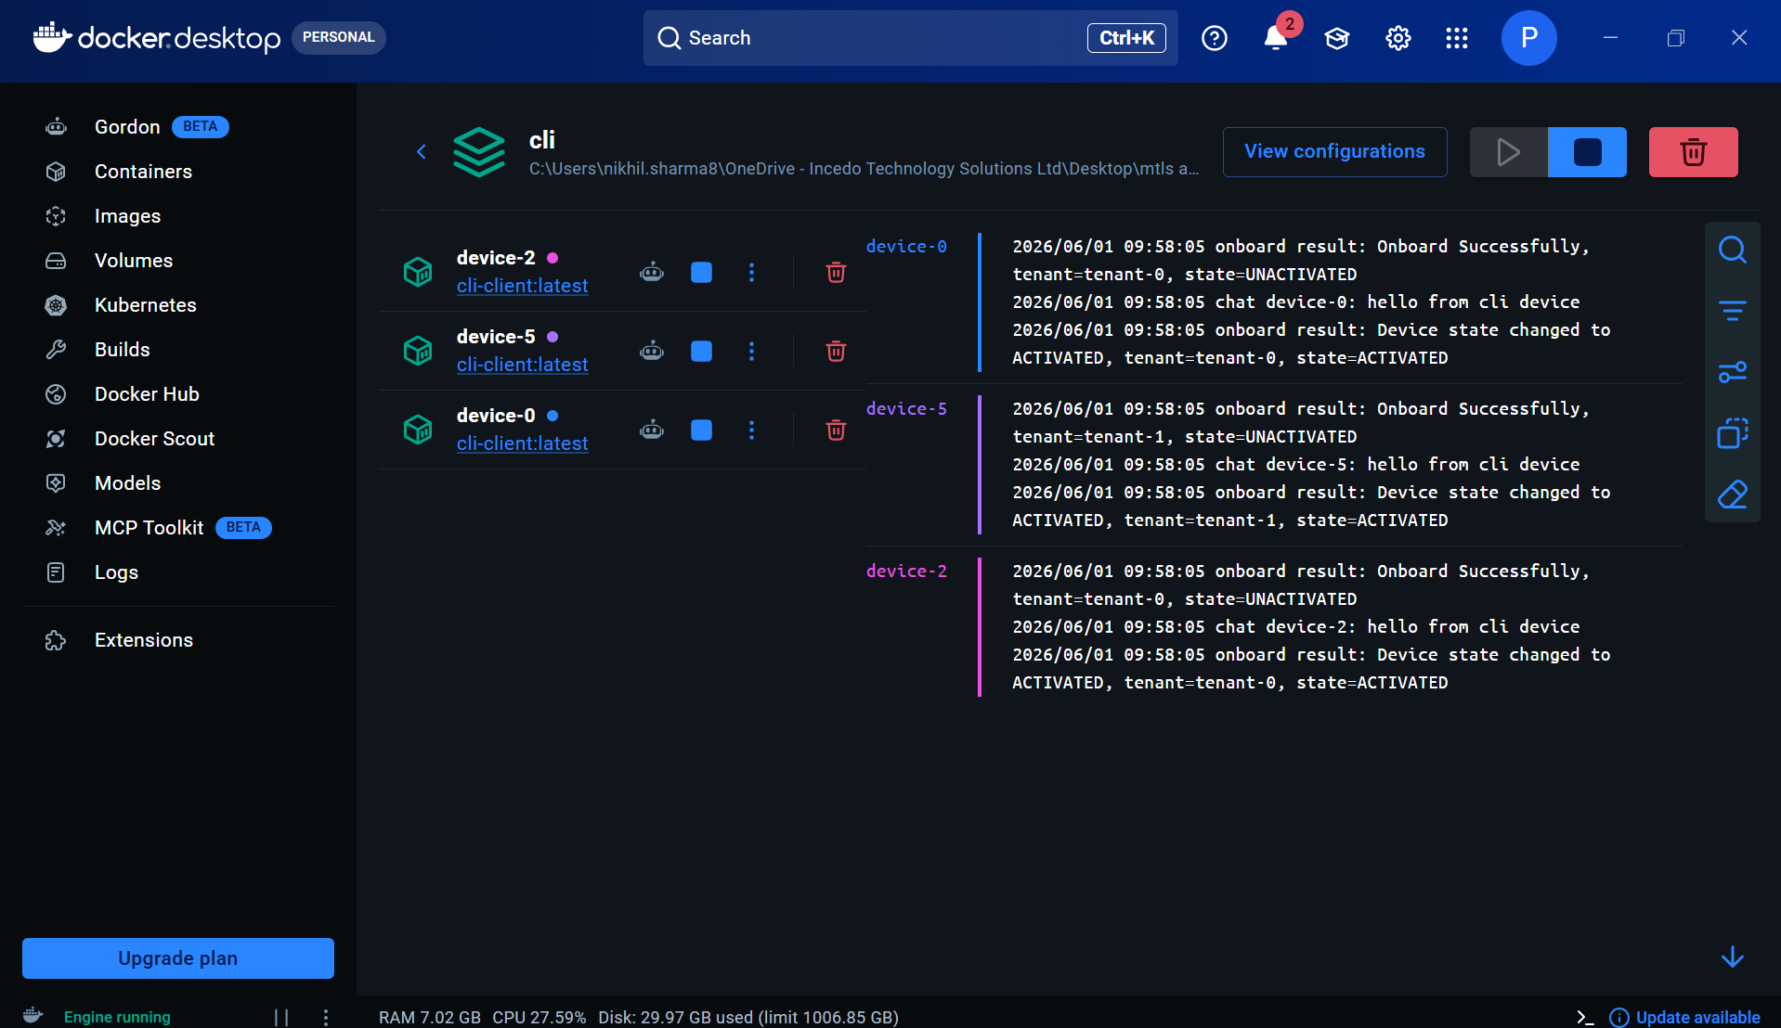 Fig 14: Docker logs simulating multiple devices onboarding

Device and Tenant Management Observations
The project additionally provided understanding of device registration workflows, tenant association mechanisms, and device lifecycle management processes. Existing onboarding architectures required manual activation keys and user intervention to associate devices with tenants. Through the proposed Zero-Touch Onboarding architecture, device identity could be verified using certificates and onboarding workflows could be automated without requiring manual activation processes.
Another significant observation was the importance of maintaining a clear separation between device identity, tenant management, and certificate trust relationships. Using certificate-based identities improves security while simplifying onboarding workflows and operational management. Understanding these concepts helped in realizing how large-scale industrial platforms securely manage thousands of devices across multiple customer environments.
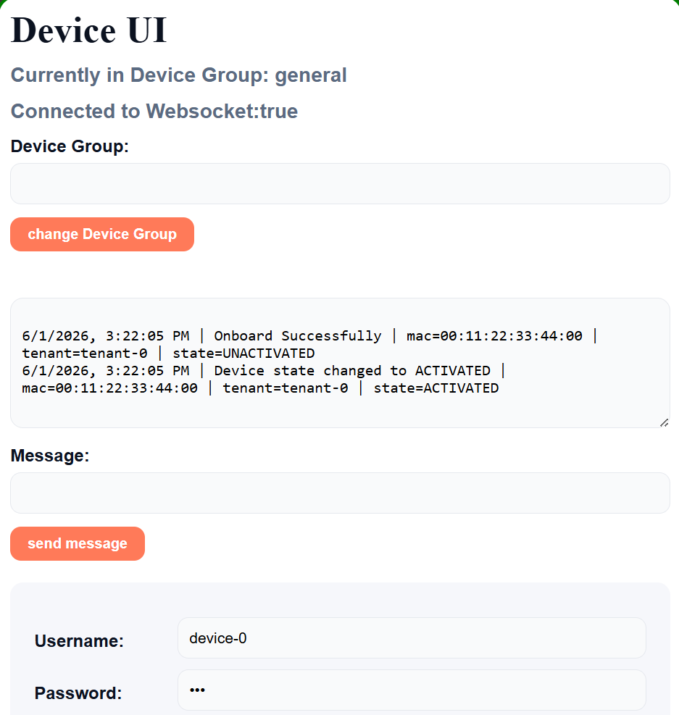
Fig 15: Device UI (showing onboarding Flow)
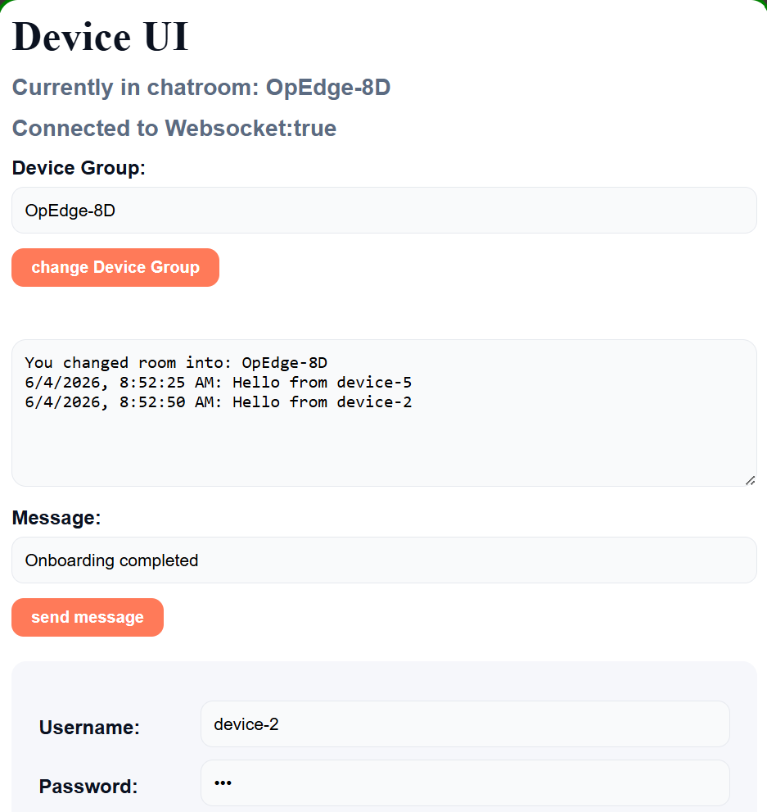
Fig 16: Device UI (showing group chat Flow)
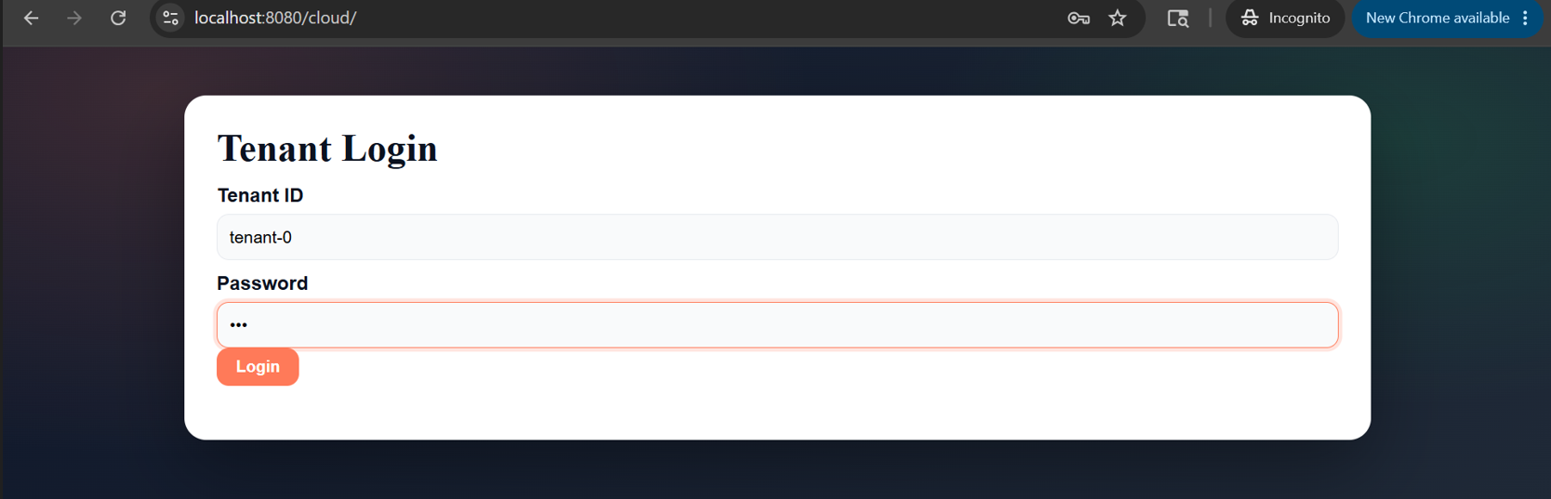
Fig 17: Tenant/Cloud UI Login

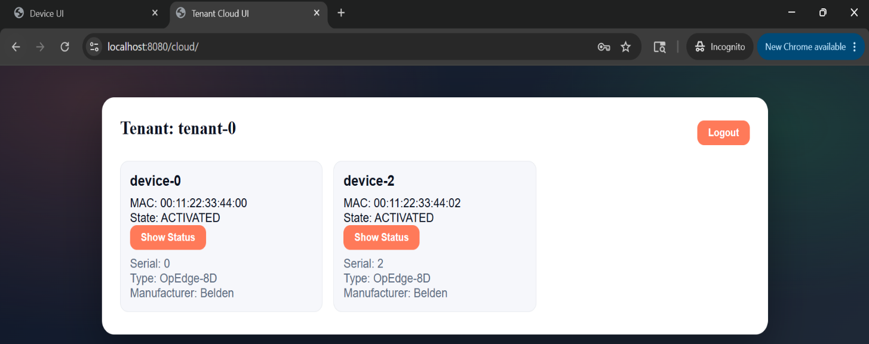
Fig 18: Tenant/Cloud UI showing successfully onboarded devices

Overall Findings
Overall, the internship provided valuable practical exposure to Industrial IoT systems, Public Key Infrastructure (PKI), certificate lifecycle management, secure communication protocols, backend software development, Docker-based scalability validation, and enterprise software engineering practices. The experience helped bridge the gap between theoretical concepts of device identity management, certificate-based authentication, secure communication architectures, and the practical implementation of Zero-Touch Onboarding systems used in industrial and enterprise environments.
The project also demonstrated how modern industrial platforms can leverage PKI, X.509 certificates, Trustpoint, CMP, mTLS, WebSocket Secure (WSS), and Golang-based backend services to automate device onboarding workflows while maintaining strong security, scalability, and operational efficiency. Exposure to these technologies provided a comprehensive understanding of enterprise-grade onboarding architectures and real-world Industrial IoT deployment practices.

Limitations

Technical Limitations
Although the internship provided significant exposure to Industrial IoT architectures, Public Key Infrastructure (PKI), certificate-based authentication systems, and secure device onboarding workflows, there were certain limitations associated with the scope of the project and the nature of enterprise security environments.
The internship involved understanding and implementing a Proof of Concept (PoC) for Zero-Touch Onboarding using PKI, Trustpoint, mTLS, WebSocket Secure (WSS), and Golang-based backend services. Due to the large-scale and production-oriented nature of industrial device management platforms, the work primarily focused on onboarding workflows, certificate lifecycle management, authentication mechanisms, and backend communication processes rather than complete end-to-end development of the entire Belden Horizon ecosystem.
The project also involved multiple interconnected components including certificate authorities, onboarding services, cloud platforms, device management systems, communication protocols, and security infrastructures. Due to the scale and complexity of these systems, fully understanding all production workflows, deployment architectures, and operational processes required extensive domain expertise beyond the internship duration.
Another limitation was that industrial onboarding systems often depend on hardware-specific security modules, production device environments, cloud infrastructures, and controlled deployment scenarios. Therefore, some onboarding validations and scalability analyses could only be performed using Docker-based device simulations and controlled testing environments.

Documentation and Security Constraints
Additionally, due to confidentiality and organizational security requirements, actual production source code, internal cloud architectures, certificate management policies, device credentials, customer deployment information, and proprietary implementation details cannot be fully documented or disclosed within this report. Therefore, generalized workflow diagrams, conceptual architectures, representative screenshots, and high-level implementation descriptions are used to explain project workflows and technical observations while maintaining compliance with industrial confidentiality guidelines.

Project Scope Limitations
Despite these limitations, the internship successfully provided practical exposure to Industrial IoT ecosystems, Public Key Infrastructure (PKI), certificate lifecycle management, secure communication protocols, backend software development, device onboarding architectures, scalability validation techniques, and collaborative software engineering practices. The experience helped in understanding how enterprise-grade security systems leverage certificate-based authentication, automated provisioning workflows, and cloud-device communication mechanisms to securely manage large-scale industrial device deployments.

Conclusions and Future Work

Conclusion
The internship provided valuable practical exposure to Industrial IoT ecosystems, Public Key Infrastructure (PKI), secure device onboarding architectures, certificate lifecycle management, and enterprise software engineering workflows used in modern industrial technology environments. The project helped in understanding how multiple components such as industrial edge devices, certificate authorities, onboarding services, cloud platforms, and secure communication systems work together to provide scalable and secure device management solutions.
A major learning outcome of the internship was the understanding of certificate-based device identity management and Zero-Touch Onboarding workflows associated with industrial edge devices. Practical exposure was gained in understanding certificate hierarchies, trust establishment mechanisms, automated certificate provisioning, device registration workflows, and secure communication architectures used within Industrial IoT environments.
The internship also provided significant understanding of Public Key Infrastructure, X.509 certificates, Certificate Management Protocol (CMP), mutual TLS (mTLS), and certificate validation mechanisms. Trustpoint and OpenSSL were extensively explored to understand certificate issuance, certificate lifecycle management, certificate chain validation, trust store configuration, and secure identity provisioning workflows used within enterprise security infrastructures.
Another important learning outcome was understanding secure communication architectures using WebSocket Secure (WSS) and Golang-based backend services. The internship helped in understanding how persistent communication channels, device authentication workflows, onboarding services, tenant association mechanisms, and lifecycle management processes can be implemented within secure onboarding platforms.
Practical exposure was also gained in testing and validation workflows associated with Industrial IoT systems. Activities involving certificate validation, TLS handshake analysis, communication debugging, Docker-based device simulation, onboarding workflow testing, issue investigation, and architecture validation helped in understanding real-world implementation challenges and software engineering practices used in industrial environments. Exposure to onboarding lifecycle management, scalability validation, backend communication workflows, and secure authentication mechanisms further strengthened practical understanding of enterprise-grade security systems.

8.2 Learning Outcomes
The internship additionally provided understanding of collaborative software engineering practices and Agile development methodologies followed in enterprise environments. Participation in Daily Scrum Meetings (DSM), sprint planning activities, Jira-based task management, collaborative design discussions, architecture reviews, and debugging sessions helped in understanding enterprise project execution workflows and software development lifecycle management practices used within large-scale industrial organizations.
Overall, the internship successfully bridged the gap between theoretical concepts of Public Key Infrastructure (PKI), certificate-based authentication, secure communication protocols, backend software engineering, and practical implementation of Zero-Touch Onboarding systems. The experience helped in developing technical understanding, debugging skills, analytical thinking, problem-solving abilities, communication skills, and professional engineering practices required for working within Industrial IoT, cybersecurity, and enterprise software development environments.

8.3 Future Work
Future work associated with the project can involve deeper exploration of Industrial IoT security architectures including hardware-backed device identities, Trusted Platform Modules (TPMs), secure key storage mechanisms, automated certificate renewal systems, and large-scale device lifecycle management platforms. Additional exposure to cloud-native deployments, infrastructure orchestration, and enterprise device management solutions can further enhance understanding of secure industrial ecosystems.
Further development can also involve implementation of advanced onboarding capabilities, automated certificate rotation mechanisms, device attestation frameworks, fleet-scale onboarding automation, and integration of enhanced monitoring and analytics systems within onboarding platforms. Exploration of advanced PKI architectures, distributed backend systems, secure edge computing environments, and next-generation identity management solutions can additionally contribute toward broader understanding of Industrial IoT security ecosystems and enterprise software engineering practices.

Bibliography

- The Go Authors, “The Go Programming Language Documentation,” [Online]. Available: https://go.dev/doc/
- Atlassian, “Jira Software Documentation,” [Online]. Available: https://www.atlassian.com/software/jira/guides
- OpenSSL Software Foundation, “OpenSSL Documentation,” [Online]. Available: https://www.openssl.org/docs/
- Cloudflare, “What is Mutual TLS (mTLS)?,” [Online]. Available: https://www.cloudflare.com/learning/access-management/what-is-mutual-tls/
- Trustpoint Project, “Trustpoint Documentation,” [Online]. Available: https://trustpoint.readthedocs.io/
- Docker Inc., “Docker Documentation,” [Online]. Available: https://docs.docker.com/.
- Gorilla WebSocket Contributors, “Gorilla WebSocket Documentation,” [Online]. Available: https://github.com/gorilla/websocket

Annexure A. Evaluation Form for Peer Review

Name of the student:  Nikhil Sharma | Roll no. of the student:  102203474
Title of the project:
Zero-Touch Device Onboarding using PKI, X.509 Certificates, mTLS, WebSocket Secure (WSS), Go
Name of the company:
Incedo Inc.
Project report | Excellent ✓ |  |  | Excellent ✓
Project poster | Excellent ✓ |  |  | Excellent ✓
Project video | Excellent ✓ |  |  | Excellent ✓
Rate the work done | 0 – 10 points | 10/10
Overall performance marks | 0 – 5 marks | 5/5
Abstract of the project:
The internship focused on understanding and implementing a Zero-Touch Onboarding (ZTO) architecture for industrial edge devices using Public Key Infrastructure (PKI), X.509 certificates, Trustpoint, mutual TLS (mTLS), and WebSocket Secure (WSS). The project involved studying certificate lifecycle management, secure device identity provisioning, automated onboarding workflows, and cloud-device communication mechanisms. Practical exposure was gained in certificate generation and validation, Trustpoint and CMP workflows, Golang-based backend development, Docker-based device simulation, testing, debugging, and validation methodologies. The internship also provided understanding of Agile development practices, collaborative engineering workflows, and enterprise-grade security architectures used in large-scale Industrial IoT environments.
Mention three strengths of the work done:
- Strong understanding of PKI, certificate management, and secure device onboarding workflows.
- Practical exposure to mTLS authentication, WebSocket communication, backend development, and Docker-based scalability validation.
- Good understanding of Agile development methodologies and collaborative engineering practices used in enterprise environments.
Useful recommendations:
- Additional exposure to production-scale Industrial IoT deployments could further enhance practical understanding of device management ecosystems.
- More involvement in advanced certificate lifecycle automation, monitoring systems, and cloud-native deployment workflows would strengthen enterprise-level exposure.
- Further study of hardware-backed security mechanisms, TPM-based identity management, and large-scale device lifecycle management systems could broaden technical understanding.
Name of the evaluator student:  Akshat Dahal |  | Roll no. of the evalu-ator student: 102217193
Signature of the Evaluator student:



